PROJECT REPORT

**ROJECT NAME**

**GAS LEAKAGE MONITORING & ALERTING SYSTEM FOR INDUSTRIES**

**TEAM ID**

**PNT2022TMID40560**

**TEAM MEMBERS** KARTHICK P

MANIKANDAN C

VIJAYA KUMAR V

VENKATESH R

**BRANCH**

Computer Science And Engineering

## INTRODUCTION

* 1. **Project Overview:**

# In today's world, safety is of the utmost importance, and certain measures must be taken at both work and home to e ensure it. Working or living in a dangerous environment necessitates specific safety measures, whether the subject is electricity or oil and gas. A type of natural gas known as "Liquified Petroleum Gas" (LPG) is compressed under high pressure and stored in a metal cylinder. LPG is extremely vulnerable to fire and can result in catastrophic damage if left unprotected near any fire source. LPG is primarily utilized for cooking and is more readily available than any other natural gas. Sadly, its widespread use makes gas leakage or even a blast a common occurrence. As a result, a system for detecting and monitoring gas leaks is required. Through a flame sensor, the system will keep an eye on fire and flame. The buzzer begins to ring when a fire is detected. Tests have shown that the system can keep track of the wastage of gas and leaks and notify the user. The performance that was produced showed that it was successful in reducing the amount of domestic gas that was wasted.

* 1. **Purpose:**

# Nowadays the home safety detection system plays an important role in the security of people. Since all the people from the home goes to work on a daily bases, it makes it impossible to check on the appliances available at home especially LPG gas cylinder, wired circuits, Etc. In the last three years, there is a tremendous hike in the demand for liquefied petroleum gas (LPG) and natural gas. To meet this access amount of demand for energy and replace oil or coal due to their environmental disadvantage, LPG and natural gas are preferred. These gases are mostly used on a large scale in industry, as heating, home appliances, and motor fuel. To monitor this gas leak, the system includes an MQ6 gas detector. This sensor detects the amount of leaking gas present in the surrounding atmosphere. In this way, the consequences of an explosion or gas leak can be avoided.

## LITERATURE SURVEY

* 1. **Existing Problem:**

# The Internet of Things aims towards making life simpler by automating every small task around us. As much as IoT helps in automating tasks, the benefits of IoT can also be extended to enhancing the existing safety standards. Safety, the elementary concern of any project, has not been left untouched by IoT. Gas Leakages in open or closed areas can prove to be dangerous and lethal. The traditional Gas Leakage Detector Systems though have great precision, fail to acknowledge a few factors in the field of alerting people about the leakage. Therefore, we have used IoT technology tomake a Gas Leakage Detector for society which has Smart Alerting techniques involving sending a text message to the concerned authority and the ability to perform data analytics on sensor readings. Our main aim is to propose a gas leakage system for a society where each flat has gas leakage detector hardware. This will detect the harmful gases in the environment and alerting to society members through the alarm and sending notifications.

## References:

Prof. M.Amsaveni, A.Anurupa, R.S.Anu Preetha, C.Malarvizhi, M.Gunasekaran; they told in their research paper on “GSM-based LPG leakage detection and controlling system” the leakage of LPG gas is detected by the MQ-6 gas sensor. Its analog output is given to the microcontroller. It consists of a predefined instruction set. Based on this, the exhaust fan is switched on. So, the concentration of gas inside the room gets decreased. Then, the stepper motor is rotated thus closing the knob of the cylinder. Because of this process, the leakage of gas is stopped. The relay is switched to off the power supply of the house. The buzzer produces an alarm to indicate the gas leakage. Then, the user is alerted by SMS through the GSM module. They proposed their methodology that the system takes an automatic control action after the detection of 0.001% of LPG leakage. This automatic control action provides a mechanical handle for closing the valve. We are increasing the security for humans by means of a relay which will shut down the electric power to the house. Also, by using GSM, we are sending an alert message to the users and a buzzer is provided for alerting the neighbors about the leakage.

P. Meenakshi Vidya, S. Abinaya, G. Geetha Rajeswari, N. Guna, “Automatic LPG detection and hazard controlling “published in April 2014 proposed the leakage detection and real-time gas monitoring system. In this system, the gas leakage is detected and controlled by means of the exhaust fan. The level of LPG in the cylinder is also continuously monitored.

Srinivasan, Leela, Jeya bharathi, Kirthik, Rajasree; in this research paper they talked about gas leakage detection and control. In this paper, the gas leakage resulting in fatal inferno has become a serious problem in households and other areas where household gas is handled and used. It alerts the subscriber through the alarm and the status display besides turning off the gas supply valve as a primary safety measure.

Hitendra Rawat, Ashish Kushwah, Khyati Asthana, Akanksha Shivhare, in the year 2014 planned a framework, they gave security issues against hoodlums, spillage, and fire mishaps. In those cases, their framework sends an SMS to the crisis number given to it

B. B. Did paye, Prof. S. K. Nanda; in this paper, they talked about their research on leakage detection and review of “Automated unified system for LPG using microcontroller and GSM module”. Their paper proposed an advance and innovative approach for LPG leakage detection, prevention, and automatic booking for a refill. In advance, the system provides the automatic control of the LPG regulator also if leakage is detected the system will automatically turn off the main switch of the power supply. Hence it helps to avoid explosions and blasts.

Pal-Stefan Murvaya, Ioan Sileaa, 2008, they told in their survey on gas leak detection and localization techniques various ways to detect gas leakage. They introduce some old or new techniques to detect the gas. The proposed techniques in this paper are nontechnical methods and hardware-based methods which include acoustic methods, optical methods, and active methods. In their survey they told a wide variety of leak-detecting techniques is available for gas pipelines.

## Problem Statement Definition:

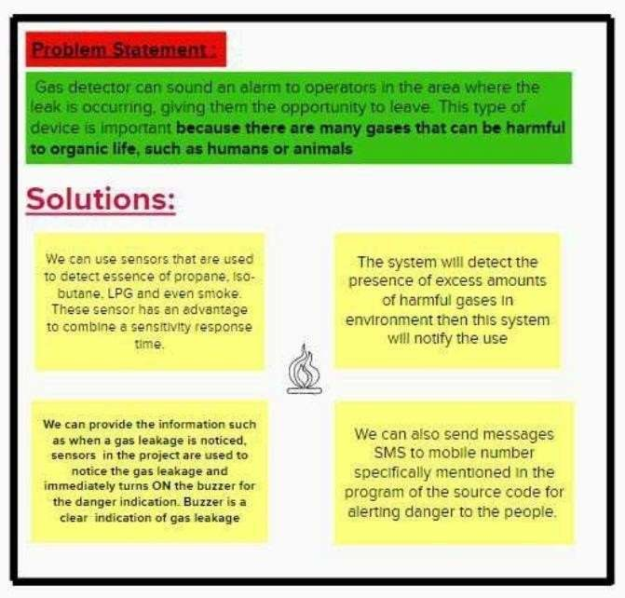

1. **IDEATION & PROPOSED SOLUTION:**

## Empathy Map Canvas:



* 1. **Ideation & Brainstorming:**

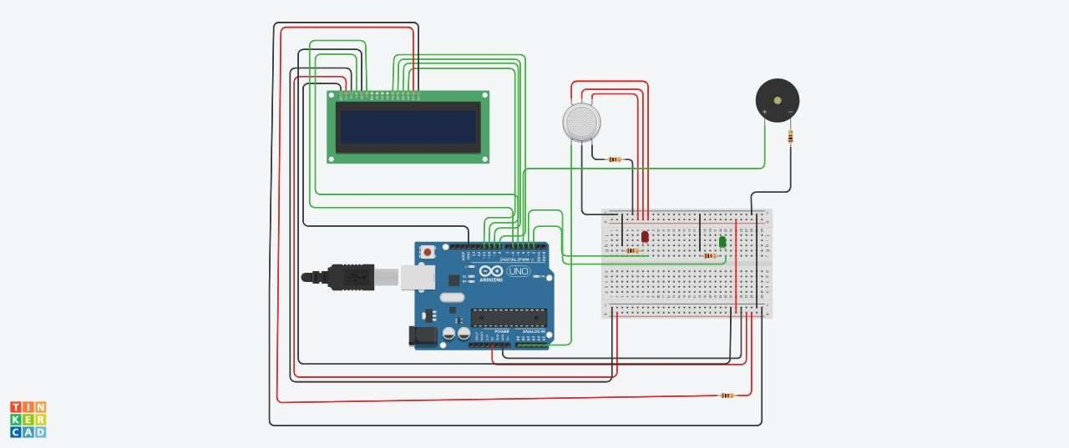

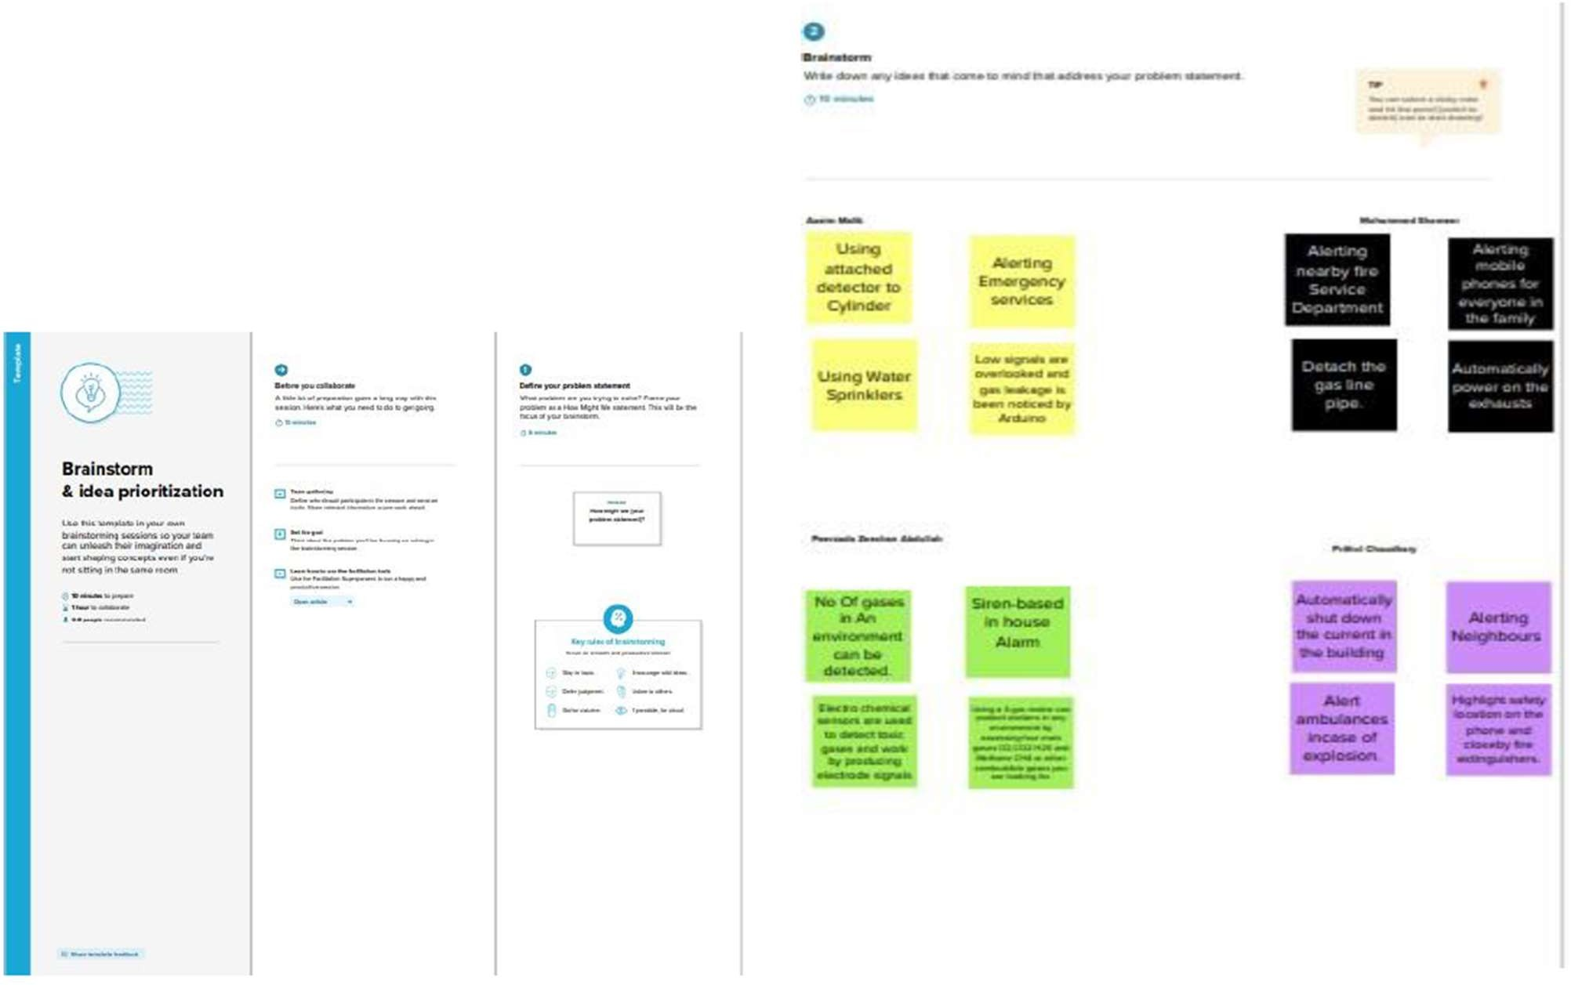

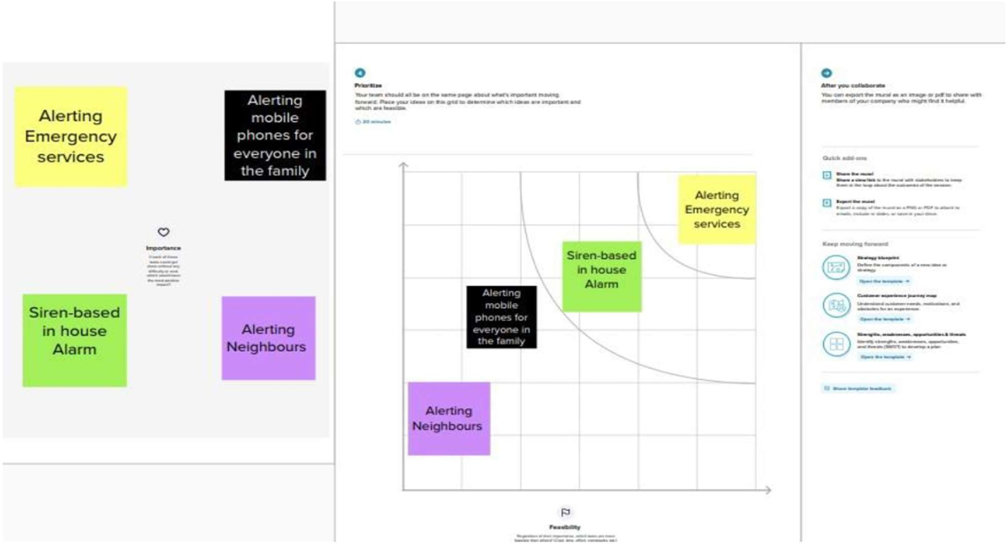

## Proposed Solution:

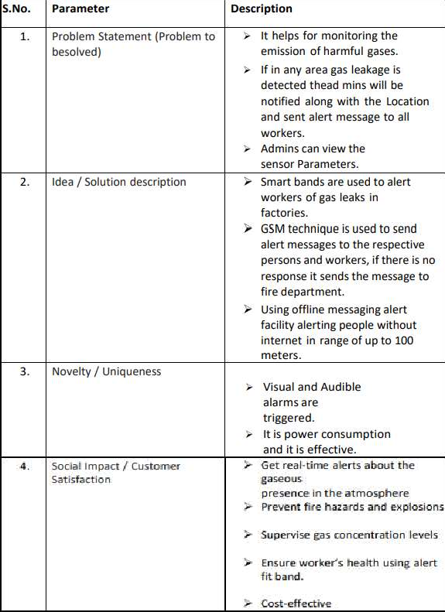

* 1. **Problem Solution fit:**

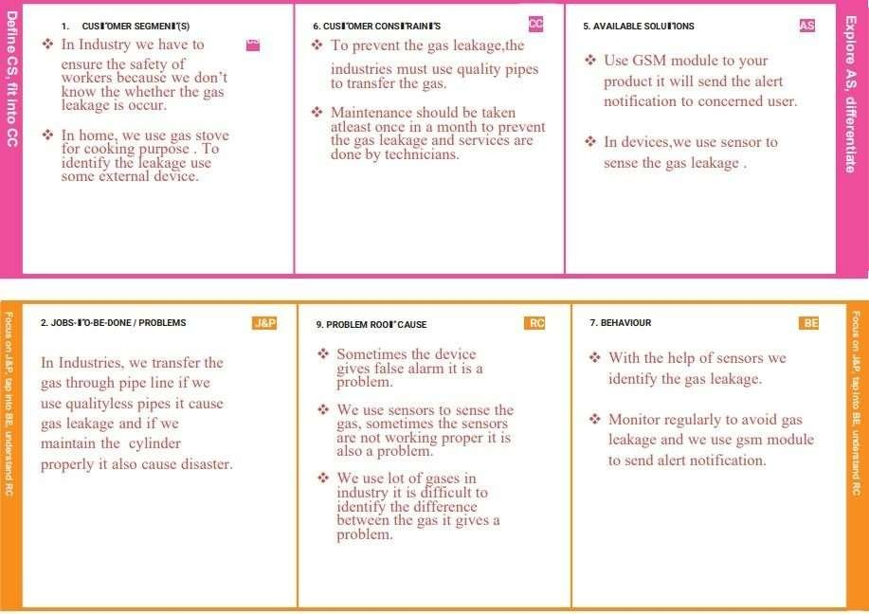

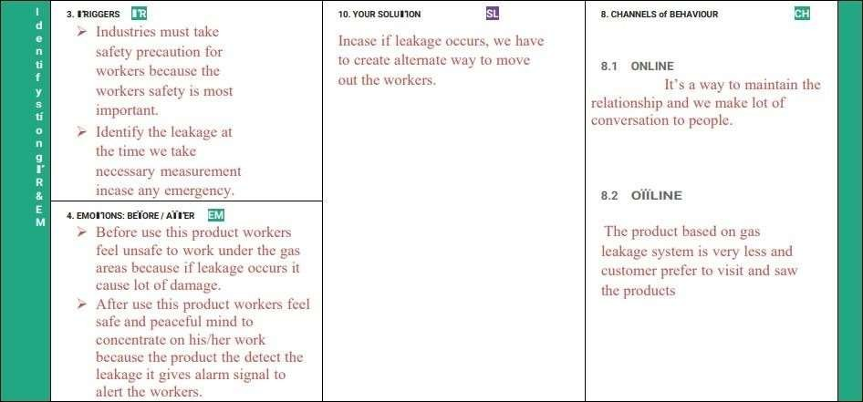

## REQUIREMENT ANALYSIS

* 1. **Functional requirement:**

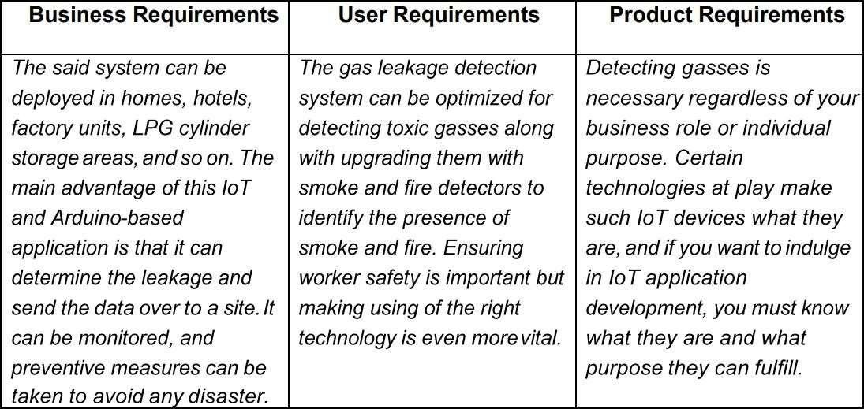

## Non-Functional requirements:

Data Gathering:

Using multiple sensors, we are going to gather the necessary data.

Data Store:

Collected data is stored in Cloud and Necessary databases.

Data Analysis:

Data from the store must be analyzed for raising alerts in case of necessity.

Data Monitoring:

Gathered data must be displayed to the user for monitoring.

## PROJECT DESIGN

* 1. **Data Flow Diagrams:**

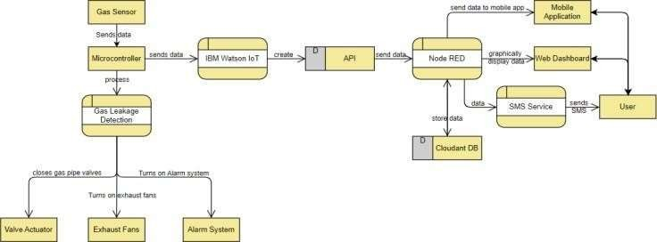

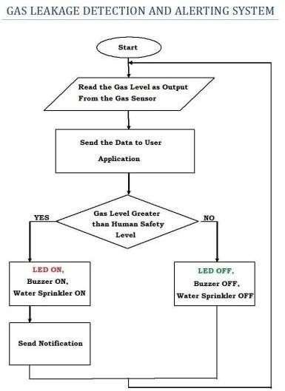

## Solution & Technical Architecture:

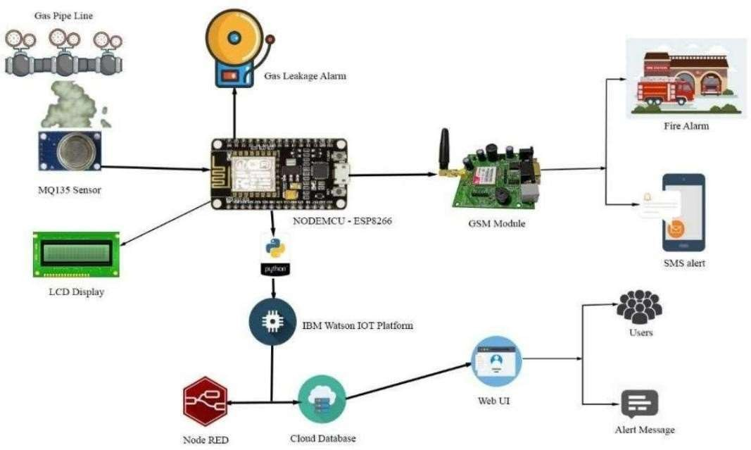

* 1. **User Stories:**

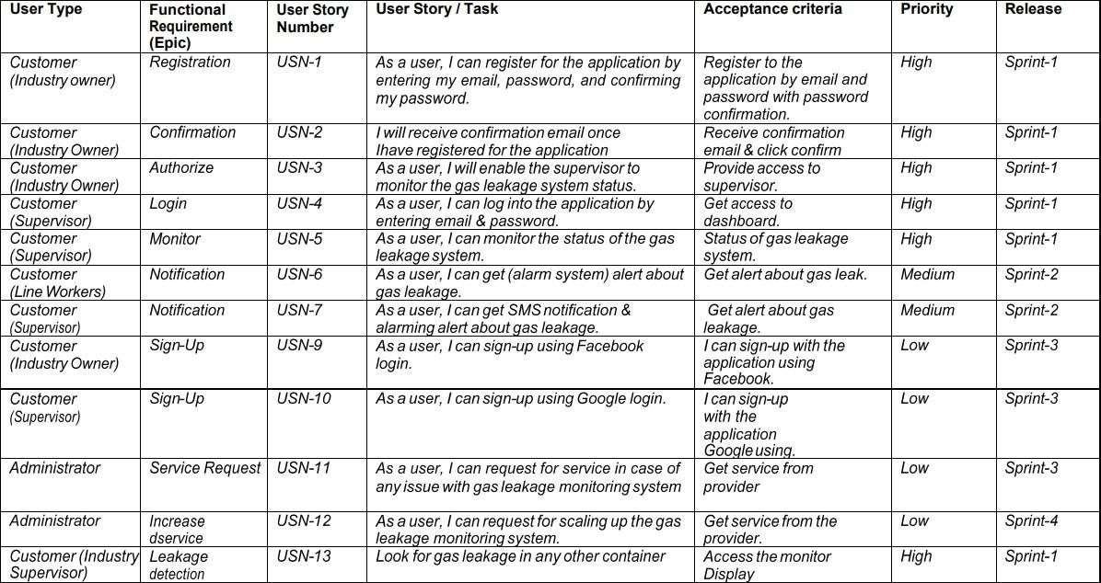

## PROJECT PLANNING & SCHEDULING

* 1. **Sprint Planning & Estimation:**
     + SPRINT PLAN
* ANALYZE THE PROBLEM
* PREPARE An ABSTRACT, PROBLEM STATEMENT
* LIST A REQUIRED OBJECT NEEDED
* CREATE A PROGRAM CODE AND RUNIT
* MAKE A PROTOTYPE TO IMPLEMENT
* TEST WITH THE CREATED CODE AND CHECK THE DESIGNED PROTOTYPE

## Sprint Delivery Schedule

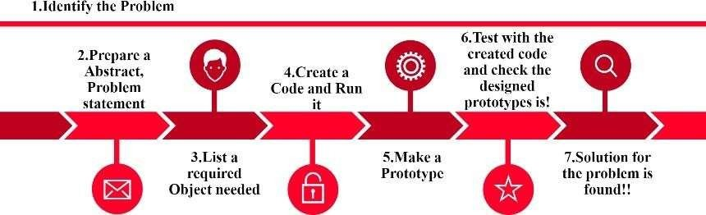

* Sprint 1
* Sprint 2
* Sprint 3
* Sprint 4

We are Developing the code in this Schedule.

## Schematic Diagram of project &Components:

* 1. **Circuit Diagram:**



## Components:

The design of a sensor-based automatic gas leakage detector with an alert and control system. The components are

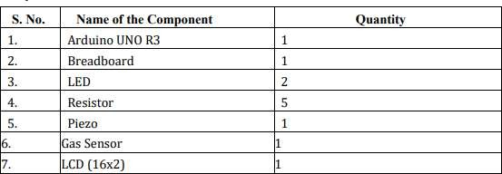

## CONCLUSION:

After this project performance can conclude that the detection of the LPG gas leakage is incredible in the project system. Applicable usefully for industrial and domestic purposes. In dangerous situations, we can save the life by using this system. An alert is indicated by the GSM module. A sensor node senses gas like CO2, oxygen, and propane. The estimated range of transmission and consumption of power is obtained. The simple procedures and Arduino UNO Micro controller area used to build the sensor.

## FUTURE SCOPE:

We propose to build the system using an MQ6 gas detection sensor and interface it with an Arduino Uno microcontroller along with an LCD Display. Our system uses the gas sensor to detect any

gas leakages. The gas sensor sends out a signal to the microcontroller as soon as it encounters a gas leakage. The microcontroller processes this signal and a message is displayed on the LCD to alert the user.

## APPENDIX:

#include <LiquidCrystal.h> LiquidCrystal lcd(5,6,8,9,10,11); int redled = 2;

int greenled = 3; int buzzer = 4; int sensor = A0;

int sensorThresh = 400; void setup()

{

pinMode(redled, OUTPUT); pinMode(greenled,OUTPUT); pinMode(buzzer,OUTPUT); pinMode(sensor,INPUT); Serial.begin(9600); lcd.begin(16,2);

}

void loop()

{

int analogValue = analogRead(sensor); Serial.print(analogValue); if(analogValue>sensorThresh)

{

digitalWrite(redled,HIGH); digitalWrite(greenled,LOW); tone(buzzer,1000,10000); lcd.clear(); lcd.setCursor(0,1); lcd.print("ALERT"); delay(1000);

lcd.clear();

lcd.setCursor(0,1); lcd.print("EVACUATE"); delay(1000);

}

else

{

digitalWrite(greenled,HIGH); digitalWrite(redled,LOW); noTone(buzzer);

lcd.clear(); lcd.setCursor(0,0); lcd.print("SAFE"); delay(1000); lcd.clear(); lcd.setCursor(0,1); lcd.print("ALL CLEAR"); delay(1000);

}

}

GitHub & Project Demo Link: h t t p s : / / g i t h u b . c o m / I B M - E P B L / I B M - P r o j e c t - 1 2 4 4 6 - 1 6 5 9 4 5 1 6 2 3

IBM IoT Watson Platform: https://7vvvul.internetofthings.ibmcloud.com/dashboard/devices/browse

Node-RED: https://node-red-cibsd-2022-11-11.eu-gb.mybluemix.net/sensor

Project Simulation: https://drive.google.com/file/d/1- PB3QA4uxNDr_JBRu4bkyAKPDtHwZFkB/view?usp=drivesdk

MIT App Inventor: <http://ai2.appinventor.mit.edu/#6204110752579584>